

CHAMPVA Claims  
Form 10-7959a

(Debut Date) April 2, 2025 |

Version 1

Revision History

| Date | Version | Description | Author |
| --- | --- | --- | --- |
| 4/2/25 | 1 | Product Debut | Mike Mooney |
|  |  |  |  |

Table of Contents

**Overview 4**

**Signed/in/signed out states 8**

**Introduction 9**

**Step 1: Signer Information 10**

**Step 2: Sponsor information 12**

**Step 3: Beneficiary information 13**

**Step 4: Health insurance information 18**

**Step 5: Claim information 22**

**Step 6: Review and sign 27**

**Error messages 31**

## Overview

VA.gov users who are the spouse or child of a Veteran with disabilities or a Veteran who has died may be able to get health insurance through the Civilian Health and Medical Program of the Department of Veterans Affairs (CHAMPVA). Users already enrolled and approved for CHAMPVA can use this form to file a claim for reimbursement. Users can log in or can access and fill out the form without signing in.

The form can be accessed directly through this URL: https://www.va.gov/family-and-caregiver-benefits/health-and-disability/file-champva-claim-10-7959a

It can also be found from the health care home page <https://www.va.gov/health-care/>:

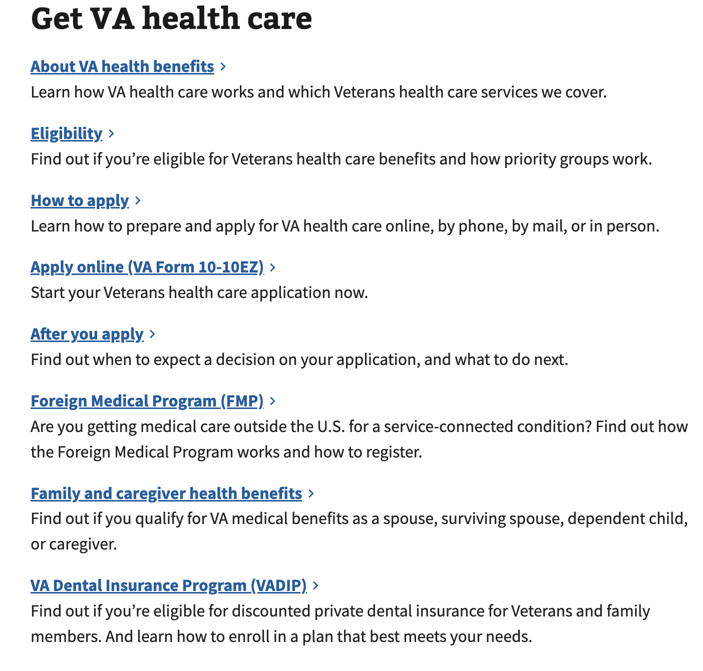

Navigating from the Family and caregiver health benefit link on the health care home page leads to the Health care for spouses, dependents, and family caregivers page.

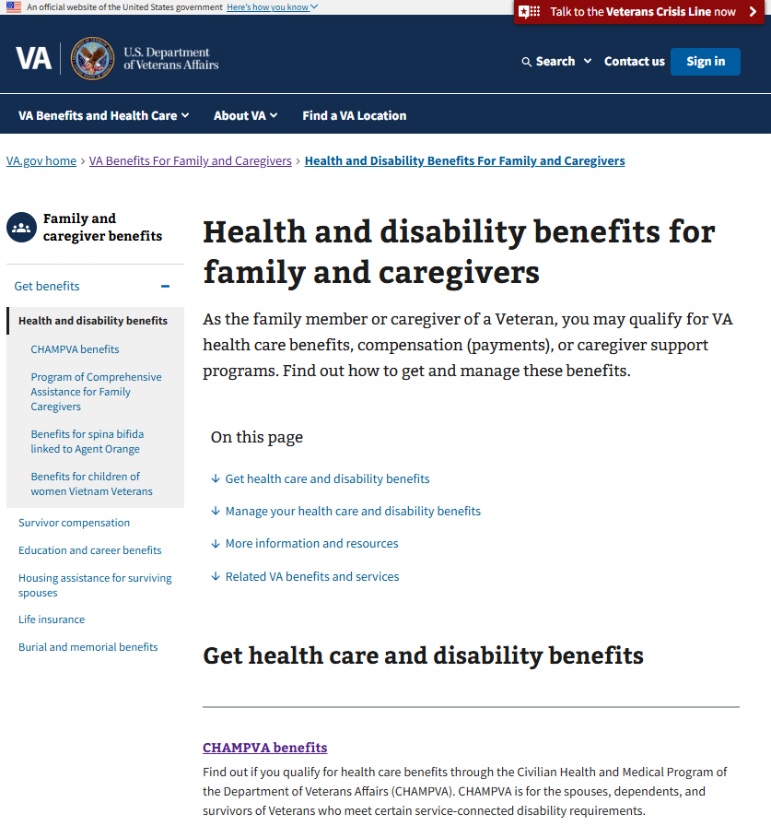

Clicking on the “File a CHAMPVA claim” link will take the user to the “File a CHAMPVA claim” page

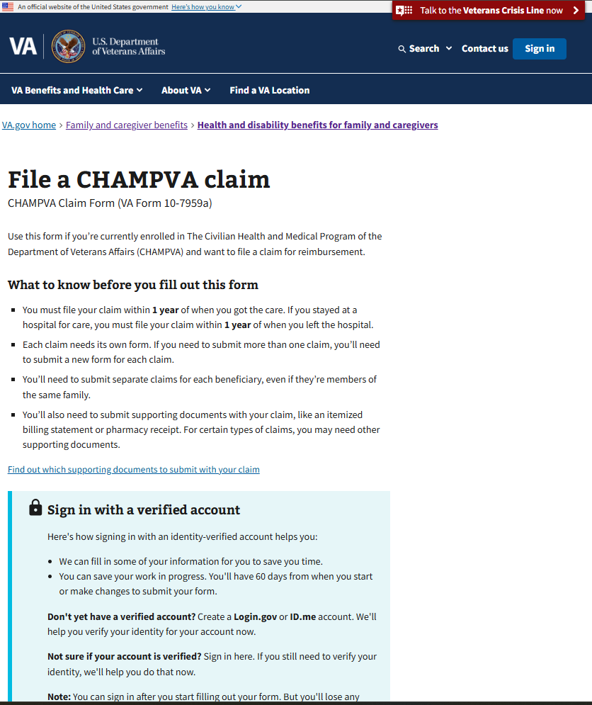  
  
Form 10-7959a can be started on this page and can also be accessed directly at https://www.va.gov/family-and-caregiver-benefits/health-and-disability/file-champva-claim-10-7959a/introduction

### Steps for this form:

1. Signer information
   1. I’m the beneficiary submitting a claim for myself
   2. I’m a Veteran submitting a claim for my spouse or dependent
   3. I’m a representative submitting a claim on behalf of the beneficiary
2. Sponsor information
   1. Name
3. Beneficiary information
   1. Name
   2. Identification
   3. Mailing address
   4. Phone number
4. Health insurance information
   1. Health insurance status
   2. Policy information
   3. Insurance type
   4. Health insurance review
5. Claim Information
   1. Claim Type
   2. Claim relationship to work
   3. Claim relationship to a car accident
   4. Upload supporting documents
   5. Upload explanation of benefits
6. Review and Sign

## 

## 

## 

## 

## 

## Signed/in/signed out states

* Signed out users can access the claims form through the introduction page. If they follow the unauthorized flow and are not signed into their VA.gov profile, they will not be able to save their progress if they leave the form before submitting.
* If the user signs in, they will be taken to the sign in screen and then able to save their progress when filling out the form.

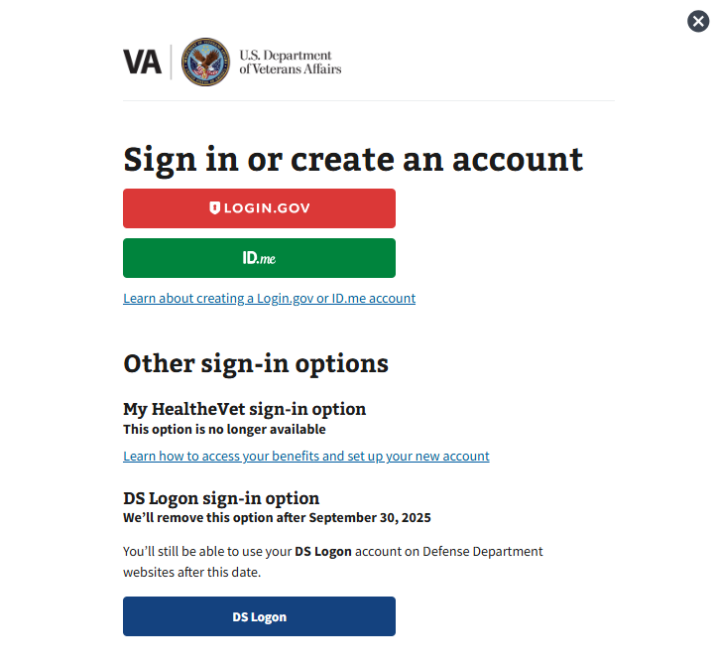

## Introduction

To start the form, click the call to action on the introduction page:

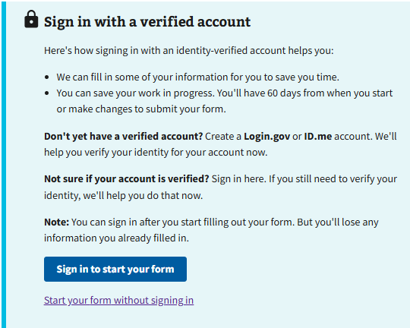

## 

## 

## Step 1: Signer Information

The user is prompted to choose an option that best describes them.

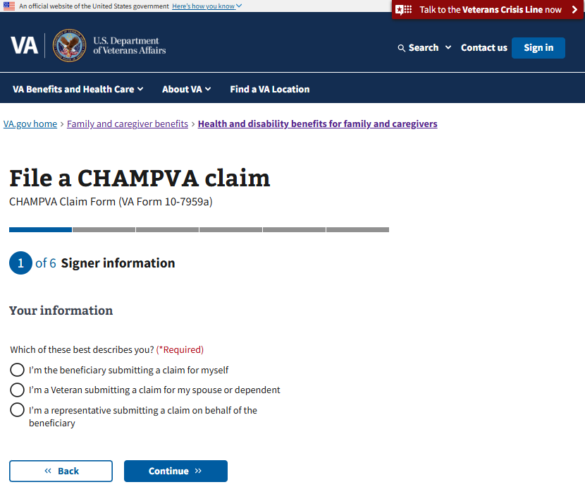

### Option A: I’m the beneficiary submitting a claim for myself

If the user selects “I’m the beneficiary submitting a claim for myself” they will proceed to the next section.

### Option B: I’m a Veteran submitting a claim for my spouse or dependent

If the user selects “I’m a Veteran submitting a claim for my spouse or dependent” they will proceed to the next section.

### Option C: I’m a representative submitting a claim on behalf of the beneficiary

If the user selects “I’m a representative submitting a claim on behalf of the beneficiary” they will be asked to provide their first and last name, mailing address, contact information, and relationship to the beneficiary on the following screens before proceeding to the “Beneficiary information” section. This contact info is kept on record in case of any problems with their form.

## 

## 

## 

## 

## 

## 

## 

## 

## 

## 

## 

## 

## 

## 

## 

## 

## 

## Step 2: Sponsor information

### 

### Name

The user must enter information about the sponsor. The sponsor’s first name and last name are required.

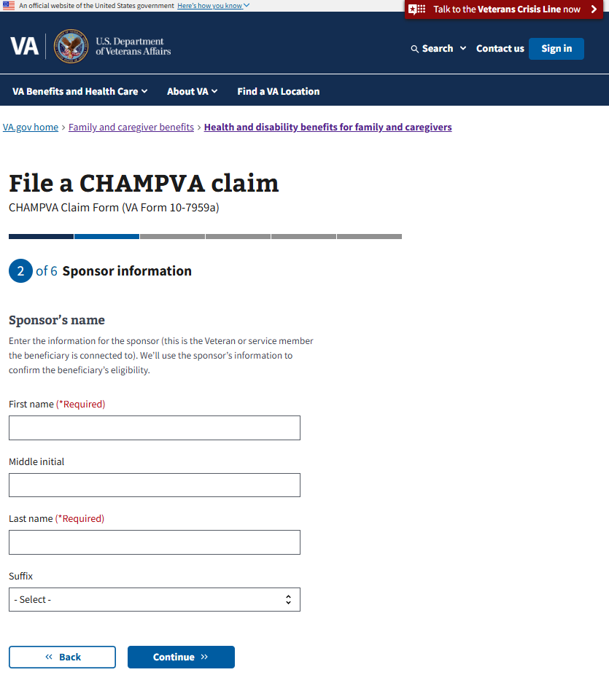

## Step 3: Beneficiary information

### Name

The user must enter information about the beneficiary. The beneficiary’s first name, last name, and date of birth are required.

### 

### 

### Identification

The user must enter the beneficiary’s CHAMPVA member number, which is usually the same as their social security number.

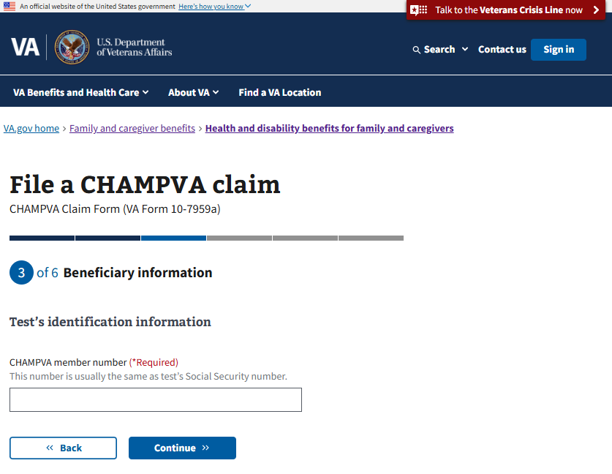

### 

### 

### 

### 

### 

### 

### 

### 

### Mailing address

If the user previously selected “I’m a representative submitting a claim on behalf of the beneficiary” at the start of the form, they will now be prompted to answer whether the beneficiary has the same address as the representative. Otherwise, they will be directed to enter the beneficiary’s address.

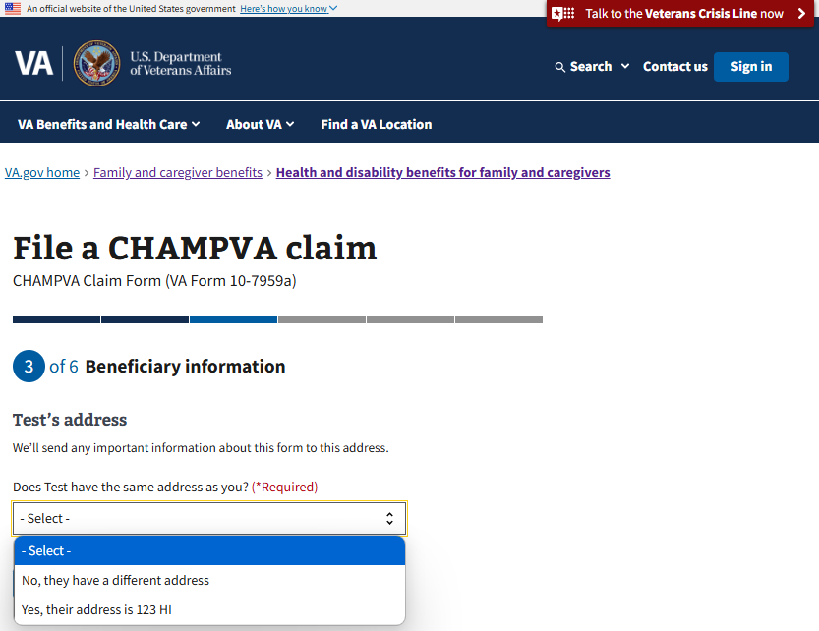

If they select ‘Yes’ it will prefill the address fields for them. If they select No, they will need to manually fill the fields.

The user now must enter or confirm the mailing address for the beneficiary.

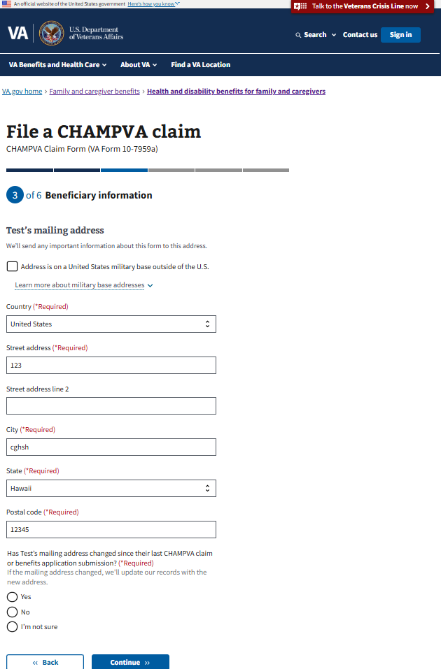

The user is also asked whether the beneficiary’s address has changed since their last form submission. The answer to this question is used during processing but does not affect how the user proceeds through the rest of the form.

### Phone number

The user must enter the beneficiary’s phone number. If someone other than the beneficiary is filling out the form on behalf of the beneficiary, they will have the option of entering the beneficiary’s email address in addition to their own.

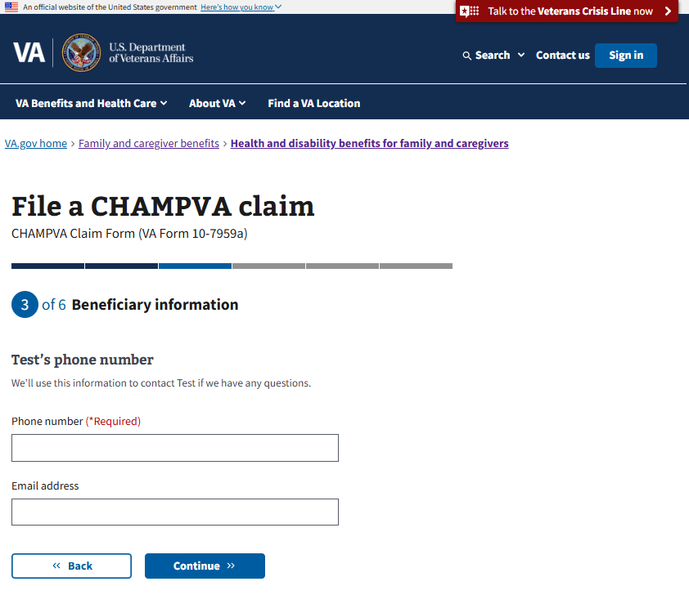

The user will then proceed to the Health Insurance information section.

## Step 4: Health insurance information

### Health insurance status

The user is required to indicate whether or not the beneficiary has health insurance information that is not through CHAMPVA, and may answer yes or no. If they answer no, they will proceed to the next section of the form. If the answer is yes, they will proceed through the following screens to provide their information.

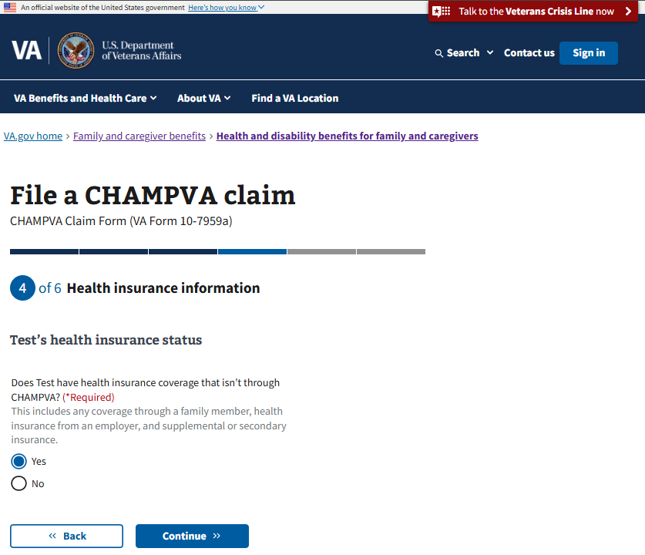

### 

### 

### 

### 

### 

### Policy information

The user must provide the name of the insurance provider

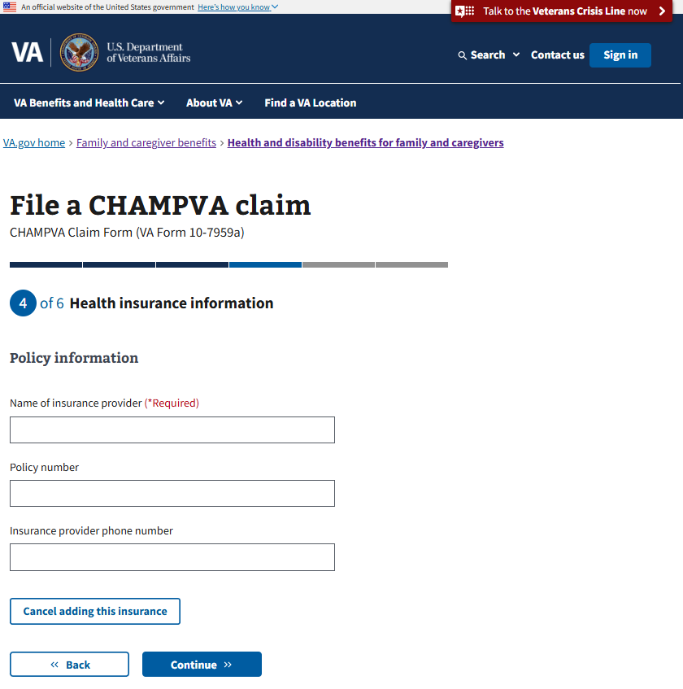

### 

### 

### 

### Insurance Type

The user must select the type of insurance the beneficiary has through this provider.

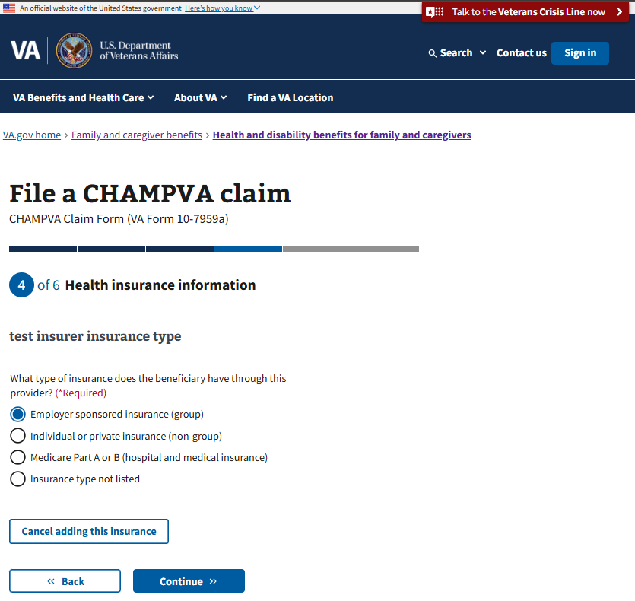

### 

### 

### 

### 

### Health insurance review

If the beneficiary has additional health insurance beyond that already entered, they can repeat the steps above for another provider or update the existing information. Otherwise, they can confirm they have none to continue.

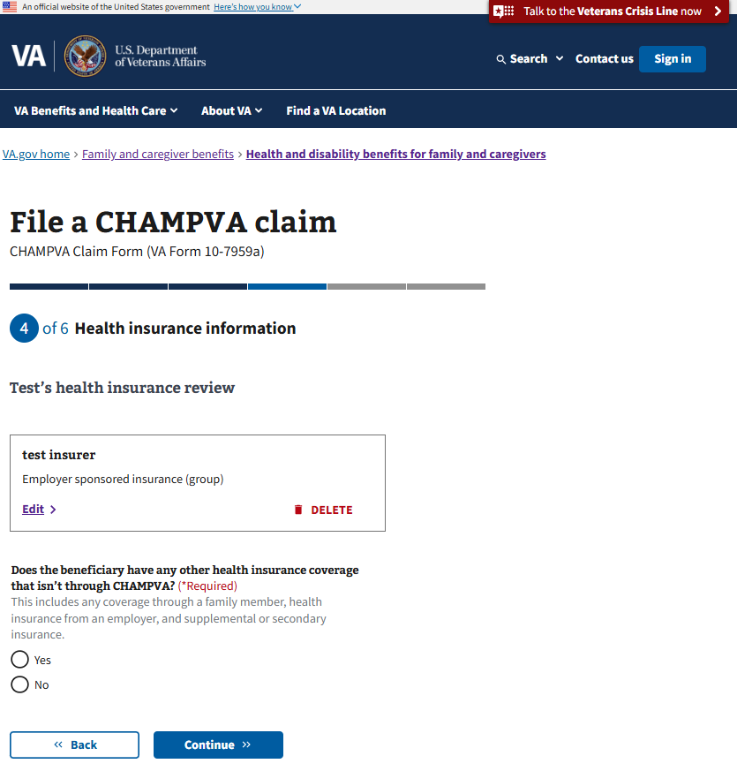

## Step 5: Claim information

### Claim type

The user must select what type of claim they are submitting

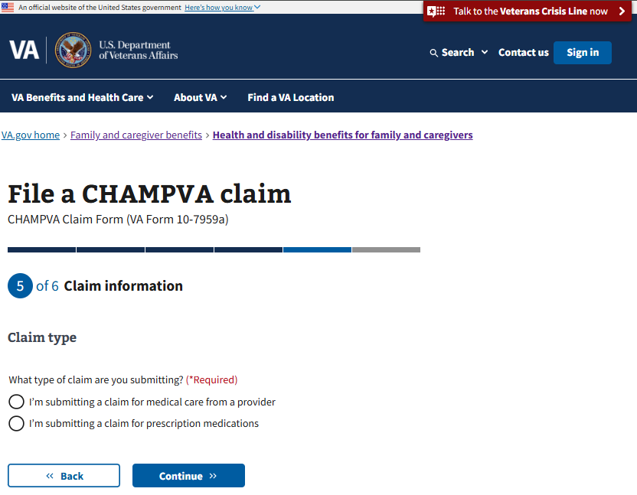

### 

### 

### Claim relationship to work

The user must select if this is a claim for a work-related injury or condition?

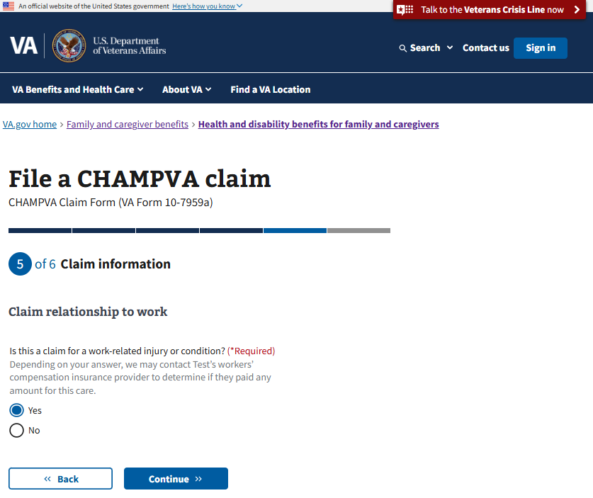

### 

### 

### 

### 

### 

### 

### 

### 

### 

### 

### 

### Claim relationship to a car accident

Is this a claim for an injury or condition caused by car accident?

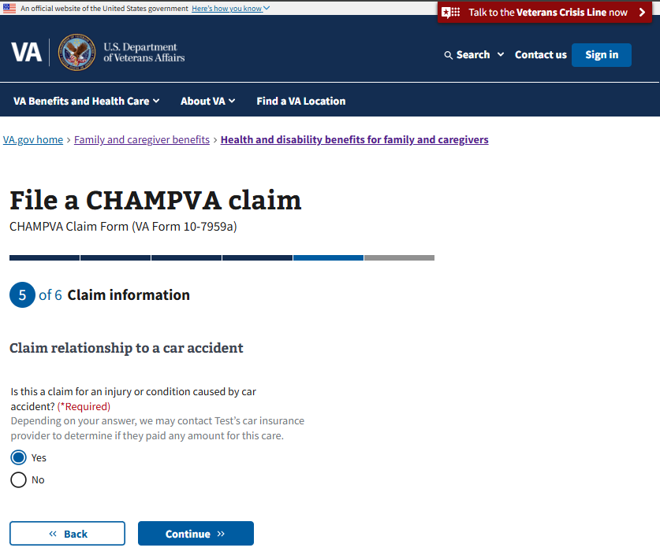

### Upload your supporting documents

The user will see a message requesting they upload the claims itemized billing statement or prescription.

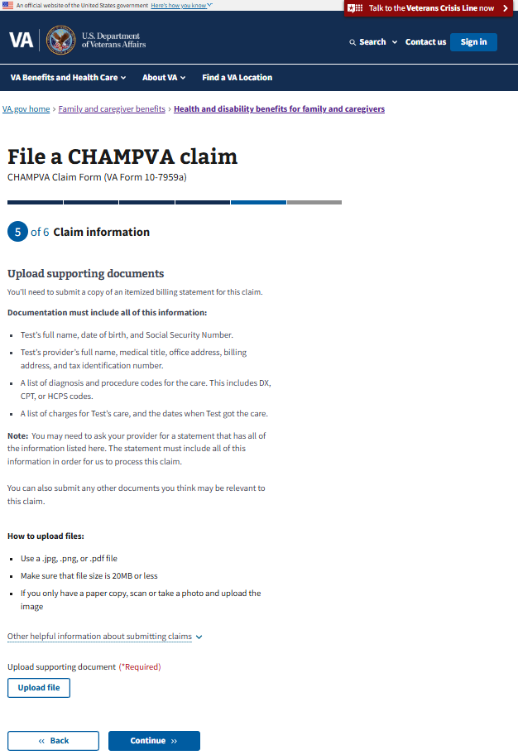

### Upload explanation of benefits

If this claim is for medical care from a provider, the user will be prompted to upload an explanation of benefits from the insurance provider. This document lists what their other health insurance already paid for their care.

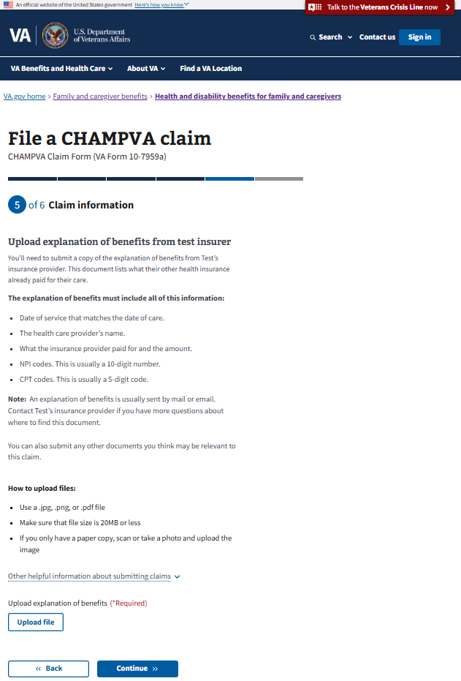

## Step 6: Review and sign

The user can review their information, sign, and submit the form on this page. They can expand any section of the form to review their information by clicking on the plus sign on the right side of the review section.

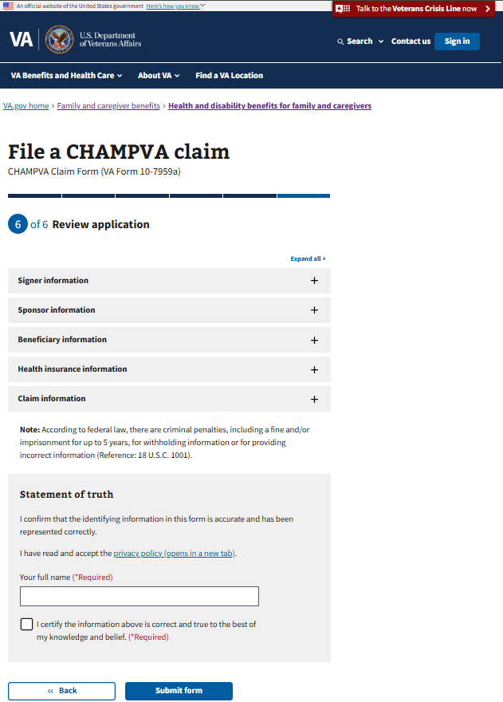

After submitting, the user should see a success message. Also see the “Error messages” section of this document for examples of what the user might see if their submit is not successful.

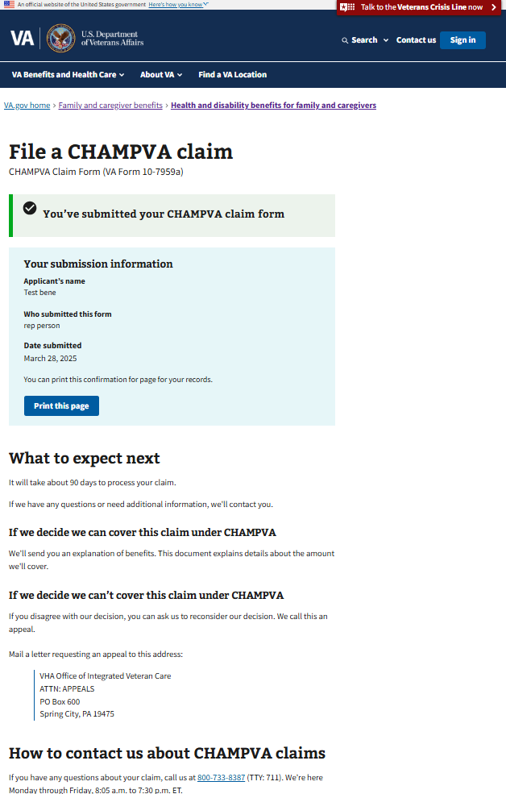

## Saved progress

If the user is signed in, their progress is saved automatically, along with their responses. If they want to leave and finish the form later, they can exit by clicking on the ‘finish this application later’ link.

If the user is signed in, when they return to the form url, they should be able to continue the form where they left off and see their saved progress.

The user can also click to start a new application, which will clear out any previously entered responses and start the form from the beginning.

## 

## Error messages

On the review page, if there is an issue submitting, the user will see this error message. (They will be able to try to submit again from this page).

For any connectivity issues during submission, this error message appears.

Required fields that are missing a response will appear outlined in red.

